CHATPER 2: CREATING A HELLO WORLD APP

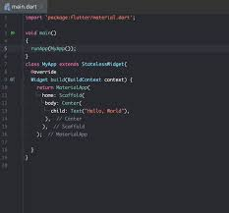Flutter is an open-source UI software development toolkit using Dart language, both created by Google. It allows developers to build natively compiled applications for mobile, web, and desktop from a single codebase. Meaning, it cuts your work by quite a bit! Here are some advantages developing mobile apps using Flutter:

